Fleet Tracking & Monitoring

FAS “next generation” solution uses commercial off the shelf programs to provide a cost effective solution for fleet managers to view a single vehicle or the entire fleet. Maximize production by providing your fleet managers the data necessary route and dispatch vehicles to increase their production. Wireless networks, Iden (Nextel & Southern LINC) CDPD and CDMA provide the connectivity. GPS connections provide data including date, time, speed and heading. Simply knowing where a vehicle is located is not enough and we have the solution. Monitor vehicle activity, engine temperature, door open/close or similar events.

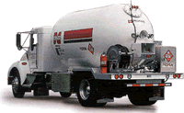
GPS tracking for your fleet makes money sense. Vehicles are a major investment, FAS “next generation” system can enhance these investments through monitoring and providing essential data.

Propane Gas Transport & Delivery

GPS LOG DATA
All data collected from units is stored electronically on the FAS server network. Download and review data to identify trends, and then use this information to maximize production from your mobile assets.

LOG EXTRACTOR

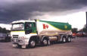
Download log files from the FAS server system and process reports in your offices to specifications you define. Identify stops made by your vehicles and the amount of time spent at each stop.

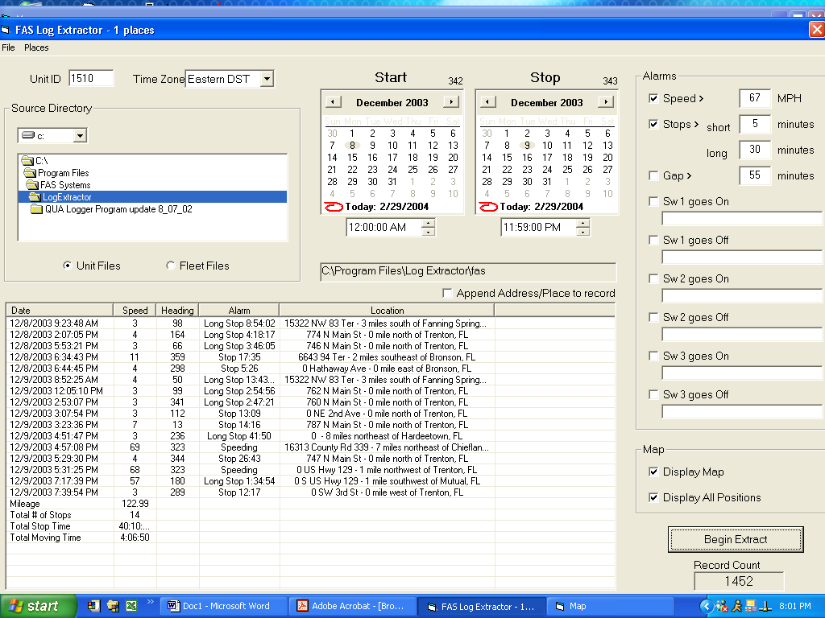
Vehicle reports
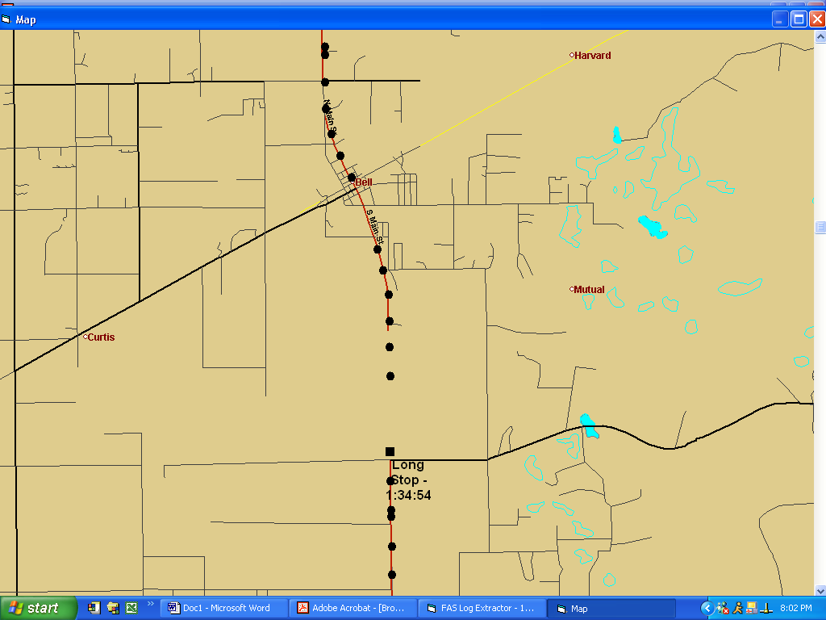
Maps
SYSTEM BENEFITS

- MONITOR VEHICLES IN REAL-TIME
- VIEW ALL VEHICLES IN FLEET ON SINGLE SCREEN
- VEHICLE DATA LOGGED TO FILE FOR REVIEW
- COMMERCIAL OFF THE SHELF SOFTWARE
- SAFETY FOR PUBLIC AND EMPLOYEES
FAS Systems, Inc.

129 Hicks Industrial Blvd.
Union Springs, Al. 36089
Phone: (334) 738-4180
E-mail: fasssytems@direcway.com

Looking to
the Future

Changed forever is the way we conduct our lives and our business. Many new government regulations place stringent requirements for business in the area of public safety. FAS “next generation” system for GPS tracking will help your company address these difficult issues.



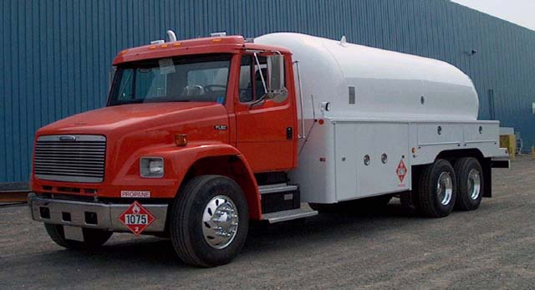
HAZARDOUS MATERIAL TRANSPORT

GPS TRACKING AND MONITORING MADE SIMPLE. NO SPECIALIZED PROGRAMS TO MASTER, NO EXPENSIVE SOFTWARE TO PURCHASE. CONTACT US AND LET US SHOW YOU HOW THE FAS “NEXT GENERATION” SYSTEM OF GPS TRACKING CAN MAKE YOUR COMPANY MONEY.

MISSION:
To assist customers with obtaining equipment in the most efficient and cost effective manner.
www.visionfinancialgroup.com

FAS Systems, Inc.

Fleet Tracking

& Monitoring

GPS/GIS AVL

PHONE (334) 738-4180
www.gpsicu.com



